**Code Analysis**

PyLint - Is a built in tool in Python that lets you check and scan if your code conforms to the PEP8 coding conventions. PyLint also detects potential errors such as if the modules are imported or if it is imported but unused and the interfaces are fully implemented in your code.

In Visual Studio Code - Python is fully supported through extensions and it’s easy to bring existing Python code into a Visual Studio project.

**Working in Visual Studio**

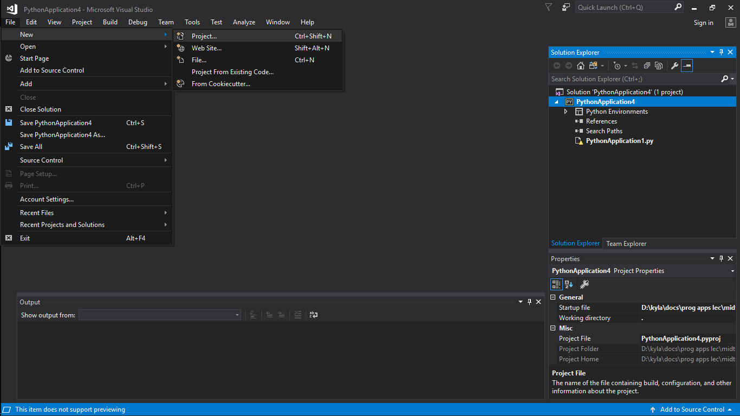

1. Creating a Python project from existing code
2. Click on File, then New, then Project or you can use the shortcut keys (ctrl+shift+N).
3. A window will pop up, select “From Existing Python code” and then give a name to the project and browse the folder where the project will be located then select OK.
4. A new window will appear and you need to set the path to your existing code, filter for the file types and specify any search paths that your projects requires but you can leave the search paths empty if you don’t that part. Click Next.

2. Running the PyLint

1. In the Solution Explorer you can see the project you created. Right Click your project and then select Python and click Run PyLint.

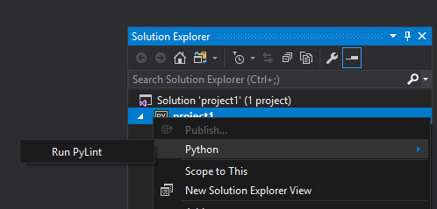

1. Once the PyLint is run. An error list will show below containing the errors, warnings and messages. In this sample there are 44 warnings and 0 errors. It is easier to detect if it is a warning or an error since it is represented by a symbol.

